Computationally Independent Model and Service Specification

Lab Result Service

0.003
Jan. 25th, 2011

Architecture Inception Team | Kunal Modi, Christo Andonyadis
Editor | Naveen Amiruddin  Jennifer Brush  Becky Angeles
Authors | Naveen Amiruddin

Document Version | Date | Author | Changes
.001 | Dec 21, 2010 | Naveen Amiruddin | Initial Draft
.002 | Dec 29, 2010 | Becky Angeles | Review
.003 | Jan 25, 2011 | Naveen Amiruddin | ESSRT team Review

Table of Contents
1 Overview and Business Case 4
1.1 Service Description and Purpose 4
1.2 Scope 4
1.3 Assumptions 5
2 Business Storyboards 6
2.1 Storyboards Overview 6
2.2 Primary Actors 6
2.2.1 People Actors 6
2.2.2 System Actors 6
2.2.3 Organization Actors 6
2.3 Story Boards 7
2.3.1 LR-SB1 – Submit a new Lab Result 7
2.3.1 LR-SB2 – Retrieve labs data 7
2.3.2 LR-SB3 – Delete labs data 7
3 Detailed Functional Model 9
3.1 Structure of the Service 9
3.2 Detail of the Capabilities 9
3.2.1 Submit Lab data for a Study 9
3.2.2 Retrieve a list of all labs for a study and a subject. 10
3.2.3 Delete labs for a study and a subject. 11
4 Profiles 13
4.1 Functional Profiles 13
4.2 Semantic Profiles 13
4.3 Conformance Profiles 15
5 System Implementation Details 16
5.1 System Runtime Interaction Details 16
5.2 Implementation/Deployment Considerations 16
6 Conformance and Compliance 17
6.1 Compliance and Conformance Statements 17
7 Appendix A - Relevant Standards 18
8 Appendix B - References 19
9 Appendix C - Glossary 20
10 Appendix D – Cross Reference Tables 21
10.1 List of Storyboards 21
10.2 Storyboards to Capabilities Mapping 21
10.3 Actors 22
11 Appendix E – Service Input Data Elements 23

Overview and Business Case
The purpose of this service is to provide a set of interfaces that enable create, read of Lab Data in the Clinical Trial Management Suite (CTMS) for a given Study and a Subject. This service will be used by various lab systems such as Laboratory Information Management System (LIMS) to create labs in the Clinical Trial Object Data System (CTODS) and other application such as Cancer Adverse Event Reporting System (caAERS), Cancer Central Clinical Database (C3D) will use the get service method to get labs for a given Study and a Subject. The out of range labs will be very critical to load into caAERS to report an Adverse Event.

Service Description and Purpose
Lab Result Service (LRS) provides a business service interface for managing Lab data for studies registered in the CTMS Suite. This service is envisioned to be called by Laboratory systems to load labs as when it receives lab data for a given subject.
Below is a list of functions LRS will provide:
- Load labs for a given Study and a Subject.
- Perform a query to retrieve a list of all labs for a given Study and a Subject.

Scope

Items | Scope / Out of Scope | Source
Provide the ability to load labs for a given Study and a Site | In Scope | Lab Data Service Scope Document
Query and retrieve labs for a given Study and a Site | In Scope | Lab Data Service Scope Document
Delete a lab | In Scope | Lab Data Service Scope Document
Update a lab | Out of Scope | Lab Data Service Scope Document

Assumptions
Assumption | Affects | Source
The Study for which the Labs are loaded must be registered | Labs will be rejected | Lab Data Service Scope Document

Business Storyboards

Storyboards Overview
The business storyboards for Lab Data are described in this section. The information provided will define the relevant stakeholders (i.e., actors), and a business narrative of the key business activities that result during the interactions in a real-world scenario.
The storyboards below describe activities that would take place when a Subject is enrolled to a study and is undergoing lab tests on a given study at a site.

Primary Actors

People Actors
Name | Role | Notes
Sally Smith | Study Subject | The subject for whom the labs are recorded
Dr. Joe Brown | Primary Investigator (PI) at a site | PI at the site where the subject is enrolled

System Actors
Name | Notes
LIMS | Laboratory Information Management System: A system for managing and recording labs data.
caAERS | Cancer Adverse Event Reporting System: A system for managing and reporting adverse events.
C3D | Cancer Central Clinical Database

Organization Actors
Name | Notes
AFMP | Acme Family Medicine Practice

Story Boards

LR-SB1 – Submit a new Lab Result

Outline | A Subject undergoes a blood test at a clinic.
Detail | Sally Smith is undergoing a treatment at AFMP. Dr. Joe asks Sally to take a blood test in a clinical laboratory. After two days, the lab results from the clinical laboratory are received and are loaded in the LIMS system.

LR-SB2 – Retrieve labs data

Outline | View the labs results for a given Study and a subject.
Detail | Dr. Joe has been notified that Sally’s lab results have been loaded. Dr. Joe searches for the desired study and subject, and then views all the labs data for Sally by retrieving the labs data.

LR-SB3 – Delete labs data

Outline | Delete the labs results for a given Study and a subject.
Detail | Dr. Joe searches for the desired study and subject, and then views all the labs data for Sally by retrieving the labs data, Dr Joe then notices the labs were incorrectly loaded and then ask the clinician to delete all the labs for Sally.

Detailed Functional Model

Structure of the Service
The following table contains a list of the service capabilities and a brief description of each.
Name | Description
Submit new lab data for a study and a subject. | This capability is used to load a lab for a study and a subject.
Retrieve lab data for a study and a subject. | This capability is used to retrieve labs data for a study and a subject.
Delete lab data for a study and a subject | This capability is used to delete (soft delete) for a study and a subject.

Detail of the Capabilities

Submit Lab data for a Study
Name [M] | Submit a lab data for a study and subject
Description [M] | Enables a client system to create a lab data with an existing study and a subject.  If successful, the system will create an activity record and associate it with the study and a subject
Pre-Conditions [M] | - None
Security Pre-Conditions [M] | Access control mechanism needs to ensure the following rules  - User must be authenticated  - User must associated to LabDataUser role  - User must have accesses to Study & Site
Inputs [M] | - Assigned Study Identifier  - Subject Identifier  - Site identifier  - MRN  - Lab test code  - Lab Results  For a complete list of input data elements please refer to Appendix E
Outputs [M] | None
Post-Conditions [O] | - Activity has been recorded in the system
Exception Conditions [M] | - Specified study does not exist  - Specified subject does not exist  - Study is closed  - Invalid data type or code value for any of the attributes  - User does not have proper credentials to load labs
Aspects left for Technical Bindings [O]
Notes [O]

Retrieve a list of all labs for a study and a subject.
Name [M] | Retrieve a list of all labs for a study and a subject.
Description [M] | Allows the client system to retrieve all labs for a given study and a subject.
Pre-Conditions [M] | Study must exist
Security Pre-Conditions [M] | Access control mechanism needs to ensure the following rules  - User must be authenticated  - User must associated to LabDataUser role  - User must have accesses to Study & Site
Inputs [M] | - Study Identifier  - Identifier (Subject Identifier or Site Identifier or MRN Identifier)
Outputs [M] | For a given Study and Subject Identifier, the service will return the associated labs. The following are some of the attributes returned by the service:  - LabResult  - StudySubject  - PerformedActivity  - PerformedStudy  - Participant  For a complete list of input data elements please refer to Appendix E
Post-Conditions [O] | - Search results returned
Exception Conditions [M] | - Specified Study and Subject does not exist
Aspects left for Technical Bindings [O]
Notes [O] | Returns an empty list when no results are found.

Delete labs for a study and a subject.
Name [M] | Delete (soft delete) all the labs for a study and a subject.
Description [M] | To delete a list of labs for a given study and a subject
Pre-Conditions [M] | Study must exist
Security Pre-Conditions [M] | Access control mechanism needs to ensure the following rules  - User must be authenticated  - User must associated to LabDataUser role  - User must have accesses to Study & Site
Inputs [M] | - Study Identifier  - Identifier (Subject Identifier or Site Identifier or MRN Identifier)
Outputs [M] | For a given Study and Subject Identifier, the service will delete (soft delete) the associated labs.
Post-Conditions [O] | - Labs are deleted (Labs are not physically deleted from the database. It will be marked as in-active and it will be not be available for services/application to view).
Exception Conditions [M]
Aspects left for Technical Bindings [O]
Notes [O] | When there are no labs to delete for a given identifier, this capability does not result in an error.

Profiles

Functional Profiles
Functional Profile No. | Functional Profile Name | Functional Profile Description | Capability Name
LR-FP1 | Lab Results Profile | This profile provides functionality to manage labs for a Study and a Subject | - Submit a Lab for a Study and a Subject  - Retrieve a list of all labs for a Study and a Subject  - Delete a list of all labs for a Study and a Subject

Semantic Profiles
Semantic Profile No. | Semantic Profile Name | Constrained Information Model | Semantic Profile Description
LR-SP1 | Clinical Trials Object Model | Lab Results Analysis Model | The Lab Results analysis model, shown below, is a subset of the CTODS analysis model. The diagram below shows the classes that will be used for the Lab Results Service
LR-SP2 | HL7 CT Lab message | HL7 CT Lab message DMIM | HL7 CT Lab message DMIM (Domain Message Information Models)

The below diagrams shows the classes and attributes of the CTODS Analysis Model and HL7v3 that are applicable to the Lab Results Service. The CTODS analysis model is harmonized to BRIDG 3.0.1

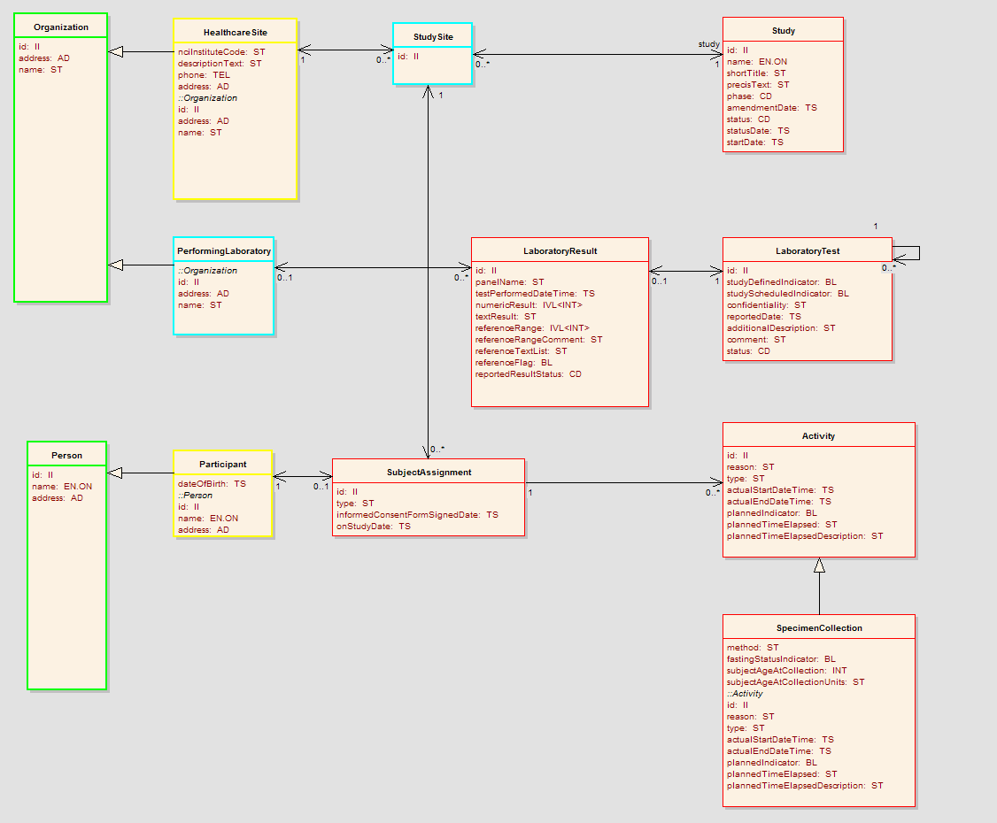
Figure 1: Lab Results Analysis Model

The diagram below shows the classes and attributes of the HL7 CT Lab message DMIM diagram

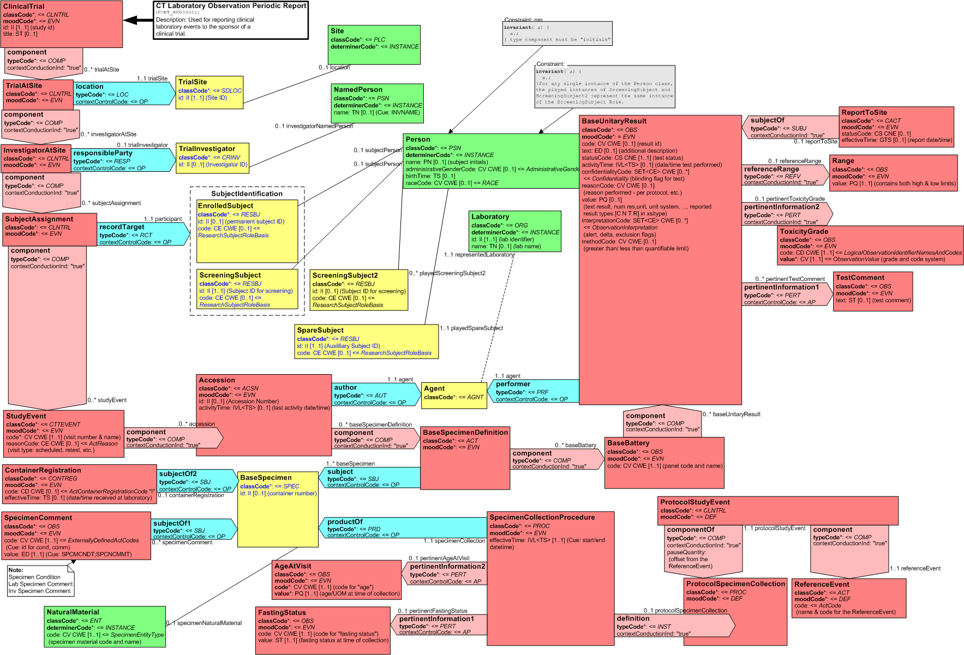

Conformance Profiles

Conformance No | LR-CP1
Conformance Name | Lab Results BRIDG Conformance Profile
Description | This is the conformance profile required for the Management functionality of the Lab Result Service
Usage Context
Mandatory | Yes
Functional Profile(s) | LR-FP1: Lab Results Functional profile
Semantic Profile(s) | LR-SP1: Lab Results Analysis Model

Conformance No | LR-CP2
Conformance Name | Lab Results HL7v3 Conformance Profile
Description | This is the conformance profile required for the Management functionality of the Lab Result Service
Usage Context
Mandatory | Yes
Functional Profile(s) | LR-FP1: Lab Results Functional profile
Semantic Profile(s) | LR-SP2: HL7 CT Lab message

System Implementation Details

System Runtime Interaction Details

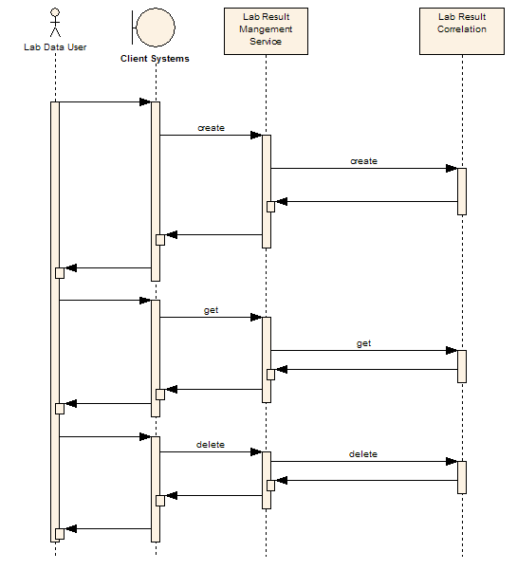`
Figure 2: Sequence Diagram

Implementation/Deployment Considerations
Implementation Considerations | Impacts
- This service is currently envisioned as a centralized service.

Conformance and Compliance

Compliance and Conformance Statements
Name | Type | Viewpoint | Description | Test method
Query Performance | Obligation | Engineering | The query for retrieving all lab data for a given Study and Subject in less than five seconds | Test cases to include performance testing.
Conformance Profiles | Obligation | Computational / Information | In order to claim a minimal level of conformance to the specification, designers/implementers are obligated to support the following mandatory Conformance Profiles (i.e. their contained functional and semantic profiles): Lab Result Service | Test cases to be defined to test each specified profile.
ISO Data types | Obligation | Information | Designers/implementers are obliged to support ISO 21090 data types in all operations with NCI localizations. | Test cases to include processing of each relevant data type
Auditing | Obligation | Engineering | Designers/implementers are obligated to decide on and document the approach for logging or auditing of operation calls | Design Review
Operation Behavior Issues / Assumptions | Obligation | Computational / Information / Engineering | Architects/Designers/Developers are obligated to confirm (or refute) all Assumptions made in the Notes for Service Realization sections of each operation and the overall Assumptions section. | Design Review

Appendix A - Relevant Standards
Name | Description | Location
BRIDG v3.0.1 | BRIDG model | http://www.bridgmodel.org

Appendix B - References
Name | Description | Location
BRIDG v3.0.1 | The CTODS is harmonized the NCI’s BRIDG v 3.0.1 | http://www.bridgmodel.org
CTODS | Clinical Trial Object Data Systems | << to be provided >>

Appendix C - Glossary
Term | Description
BRIDG | The Biomedical Research Integrated Domain Group (BRIDG) has developed a comprehensive domain analysis model representing protocol-driven preclinical and clinical research.
CP | Conformance Profile
FP | Functional Profile
LDS | Lab Data Service
SP | Semantic Profile
CTMS | Clinical Trial Management Suite
LRS | Lab Result Service
LIMS | Laboratory Information Management System
caAERS | Cancer Adverse Event Reporting System
C3D | Cancer Central Clinical Database
CTODS | Clinical Trial Object Data Systems

Appendix D – Cross Reference Tables

List of Storyboards
# | Name | Description | Source
LR-SB1 | Create | The Lab data from a LIMS systems is loaded to CTODS for a particular Subject who is undergoing a treatment in a lab. | Story Board Document
LR-SB2 | Retrieve | Dr. Sally smith requested from her system administrator a list of all Lab Data information for a particular subject. | Story Board Document
LR-SB3 | Delete | Dr. Joe searches for the desired study and subject, and then views all the labs data for Sally by retrieving the labs data, Dr Joe then notices the labs were incorrectly loaded and then ask the clinician to delete all the labs for Sally | Story Board Document

Storyboards to Capabilities Mapping
# | Storyboard | Capabilities | Functional Profiles
LR-SB1 | Submit a new Lab Data | - Add Labs Data to a Participating Site and a Study | Lab Results Functional Profile
LR-SB2 | Retrieve all Lab Data for a Study and a Subject | - Retrieve a list of all Lab Data for a Study and a Subject | Lab Results Functional Profile
LR-SB3 | Delete Lab Data for a Study and a Subject | - Delete Lab Data for a Study and a Subject | Lab Results Functional Profile

Actors
Actors | Functional Profile | Type | Operations used
Lab Data User | FP1 | Person | Create, Retrieve & Delete Lab Data for a particular Study and a Subject
Local Laboratory Information Management system | FP1 | System | Create, Retrieve & Delete Lab Data for a particular Study and a Subject

Appendix E – Service Input Data Elements
The table below lists of input data elements for this service.
Element | Note
Assigning Authority Name
Extension | Study Identifier
Root | Root value of the assigning authority
Title | Study title
trial Site Id | Healthcare site where the lab test are conducted
Investigator at site | Site PI where the lab test are conducted
Subject Assignment Identifier | MRN of the subject at a site
Subject Person | Subject who is undergoing the clinical test
Subject race | Race code
Subject gender | gender code
Study Event
Reason code
accession number
Central Laboratory
Specimen

